**The Rivers Secondary College Lismore Campus BYOD Programme**

**Device Specifications**

**The BYOD programme is new, but your device doesn’t have to be.**

If you have an existing device and it meets the minimum specification requirements, then you are welcome to use it at school.

In some cases, your existing device may only need the addition of a new USB Wi-Fi adapter to make it compatible on the school network!

If you do require the purchase of a new device, it is recommended that you have a copy of the minimum requirements on hand as different operating systems and device types have different capabilities. There are some base features that are mandatory for all devices to ensure the device is capable for learning activities.

**Please be advised that mobile phones, iPods and tablets with a display smaller than 9.7” are not appropriate as a primary device for BYOD.**



BASE REQUIREMENTS

Display

Minimum 9.7” display

Display should be no larger than 13.3” as this has an adverse effect on weight and battery life. Ideal size is 11”.

Display resolution will not affect learning activities.

Touchscreen input not required for learning activities.

Weight (recommendation)

Aim for a device UNDER 1.5-2kg, or a weight you are comfortable carrying around each day. Remember you will be carrying this and potentially some books in your bag each day.

Physical Keyboard

Device must have a physical keyboard for data entry.

USB/Bluetooth Mount not required but can be beneficial.

Tablet devices using aftermarket keyboards may affect battery life.

WiFi

Minimum:

802.11n (5GHz). Also referred to as Dual Band a/b/g/n

Recommended:

Dual Band (2.4GHz/5GHz) 802.11ac.

Battery Life

Minimum 6 hours

**Device is expected to be charged at home each day. Facilities will not be available to charge the device during school hours.**

Operating System Requirements

Operating System Processor Memory Storage

(CPU)



Celeron/Pentium or 4GB RAM 128GB equivalent equivalent (minimum)

i3/i5/i7 or equivalent (recommended)

Microsoft Windows

Any CPU

Late 2013 or newer 4GB RAM 128GB

SSD +

Apple MacBook

Any CPU 2GB RAM 32GB (minimum)

Samsung Galaxy Tab

S2 9.7” WiFi or equivalent

Android

6th generation iPad or 2GB RAM 32GB (minimum) newer (late 2014)

- Present)

**Other Considerations**

- System life expectancy is 4 years (not including physical damage/wear and tear).

Meaning that students entering year 7 can utilise any device, but may require a new one entering senior years.

- Depending on senior electives, a year 7 device could be used through until graduation.

Purchasing a solid, robust device will assist in the device’s survival.

- Students entering year 9-12 need to consider their electives and the software requirements when selecting a device for school.

- Extended warranties are often available, and insurance for your device can also be found and applied when purchasing a new device. Check all the terms and conditions to ensure what is included/covered and always make a decision based on your personal circumstances.

**Accessories**

- Specialised back pack: with Laptop/Tablet compartment for added protection.

- Carry Case: A protective case to house the device is highly recommended.

- Tablet case with integrated keyboard.

- Additional storage: An external HDD may be desirable in some circumstances, either to supplement a small internal HDD or as a backup for data not saved online.

**How to Access School WiFi on your BYOD Device**

Students need to go to the Network settings on their laptop and locate the network detnsw

They must enter their allocated username@detnsw followed by their password to successfully connect to the internet.

If there are any problems the student will need to speak to the class teacher or the TSO in the Library.



BYOD Software

NSW Department of Education Software





Students with a current NSW Department of Education email address are able to download Microsoft and Adobe software **free of charge.** While all the software available from the DoE is Microsoft Windows compatible, Apple MacBook’s only have limited compatibility while **Chromebooks and Tablets (both Android and IOS) have no software available to them.**

Titles include Microsoft Windows 10, Microsoft Office 2016 for Windows and Mac and Adobe Creative Cloud for Windows and Mac.

You can access the NSW Department of Education Software Catalogue from the website below.

http://nsw-students.onthehub.com/

Get the essentials for Windows and Apple



G-Suite

G- Google Suite of application are the preferred set of office utilities at Lismore High Campus. This suite of applications offers excellent collaborative features which greatly enhance student learning. To access G-Suite simply login to your student portal, use the left navigation shortcuts to select **Learning and select G Suite (Google** **Apps for Education).** From there you’ll find everything you need.



Google Chrome

Google Chrome is the preferred internet browser at Lismore Campus, this is the access portal for almost all in class activities, projects and take home assessments.

Microsoft Office 365



Microsoft Office 365 is a powerful set of utilities which offer many features comparable to G-Suite, OneNote is a useful tool workbook replacement in many circumstances. Office is one of the fundamental tools used throughout almost all businesses. Office 365 has cloud storage and can be accessed in a web browser or installed on up to 5 PCs or Macs, 5 tablets and 5 Smartphones. **Office 365 is accessed through the** **Student portal under the learning tab.**

**BYOD Services**

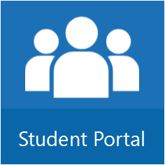Department of Education Student Portal is your access to your student email address, timetable, Microsoft Office 365, Google Apps both having unlimited cloud storage. Full versions of

Adobe Creative Cloud and Microsoft Office are available free.

Access your student portal at <http://student.det.nsw.edu.au/> with your username and password. Please ensure you are always using a current password. The student portal alerts you if your password is about to expire.



Boost student outcomes and expand upon learnings with thousands of digital educational videos, mapped to the Australian Curriculum.

Access ClickView Online at

https://online.clickview.com.au/libraries

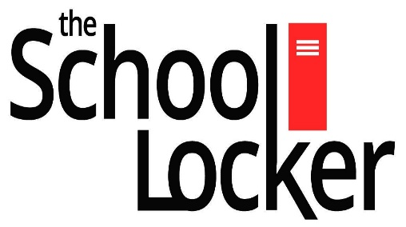

For your convenience School Locker has a suitable device available for purchase for the price listed below. If you are interested in purchasing this device **please see or phone Ms**

**Hilliard in the library for further instructions to order.**

The Rivers Secondary College, Lismore High Campus has no affiliations with School Locker, nor do we suggest that School Locker is the only option for buying laptops. There are many good deals to be found at retail stores and online sellers.